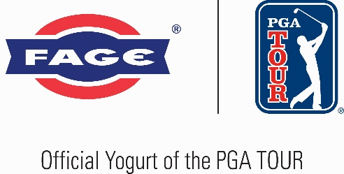

FOR RELEASE: January 20, 2026
CONTACT: Justin Johns, PGA TOUR, justinjohns@pgatourhq.com

PGA TOUR unveils new marketing partnership with FAGE Yogurt
Renowned Dairy Brand Becomes Official Yogurt of PGA TOUR and PGA TOUR Champions

PONTE VEDRA BEACH, Florida – The PGA TOUR and FAGE, the famed dairy and yogurt brand, today announced a new marketing partnership that designates FAGE as the Official Yogurt Sponsor of the PGA TOUR and PGA TOUR Champions.

The multi-year agreement will allow FAGE to provide its premium Greek yogurt at select events across the PGA TOUR season.

“We are pleased to welcome FAGE as an official partner, whose long history of providing high quality products to customers makes them an ideal brand to align with,” said Dan Glod, PGA TOUR Executive Vice President, Corporate Partnerships. “The PGA TOUR is thrilled to have FAGE join our marketing partner family and excited to have their products available for our players and fans this season.”

Founded by the Filippou family in a small dairy shop in Athens, Greece a century ago in 1926, FAGE takes pride in crafting exceptional dairy products from the freshest ingredients, creating its signature rich and creamy yogurt from a recipe passed down from generation to generation.

Jeffrey Scipione, FAGE’s Chief Commercial Officer commented: “This is a special moment for the FAGE brand, marking an important milestone in our journey and reinforcing our commitment to excellence. Becoming part of a leading tour is a cornerstone of our efforts to build meaningful connections with fans and elevate the sport at every level. It’s truly inspiring to be present at these prestigious events that bring together the world’s best players.”

The name FAGE, which in Greek is the imperative of the verb “to eat,” is still family owned and made in upstate New York in state-of-the-art facilities.

###
About PGA TOUR
By showcasing golf’s greatest players, the PGA TOUR engages, inspires and positively impacts our fans, partners and communities worldwide.
The PGA TOUR, headquartered in Ponte Vedra Beach, Florida, co-sanctions events on the PGA TOUR, PGA TOUR Champions, Korn Ferry Tour, PGA TOUR Americas and administers PGA TOUR Q-School presented by Korn Ferry and PGA TOUR University. PGA TOUR members represent the world’s best players, hailing from 28 countries and territories. Showcasing the biggest moments in the sport with history and legacy on the line, the PGA TOUR operates PGA TOUR Studios–a state-of-the-art production studio redefining golf content for fans worldwide—and has long-term domestic distribution partnerships for broadcast coverage on CBS, NBC and Golf Channel, with video streaming service on ESPN+ and additional coverage on multiple Free Ad-Supported Television (FAST) channels. Internationally, the PGA TOUR Studios-produced World Feed is available across 200+ countries and territories in 30 languages via 39 broadcast and digital partners. To date, events across all Tours have generated more than $4 billion in charitable giving. Fans can follow the PGA TOUR at PGATOUR.COM, on the app and in multiple languages across their favorite social media pages.

About FAGE
FAGE is a leading dairy company passionate about sharing the finest dairy products with food lovers around the globe. Founded in Greece in 1926, FAGE has grown from its Greek roots into an international brand, offering exceptional dairy products in over 30 countries. Best known for its signature Greek strained yogurt, FAGE continues to inspire healthy lifestyles and deliver deliciously crafted products.

